User Acceptance Testing (UAT) Template

Date Team ID
Project Name Maximum Marks
3 December 2025

SHOPEZ : E-commerce Application

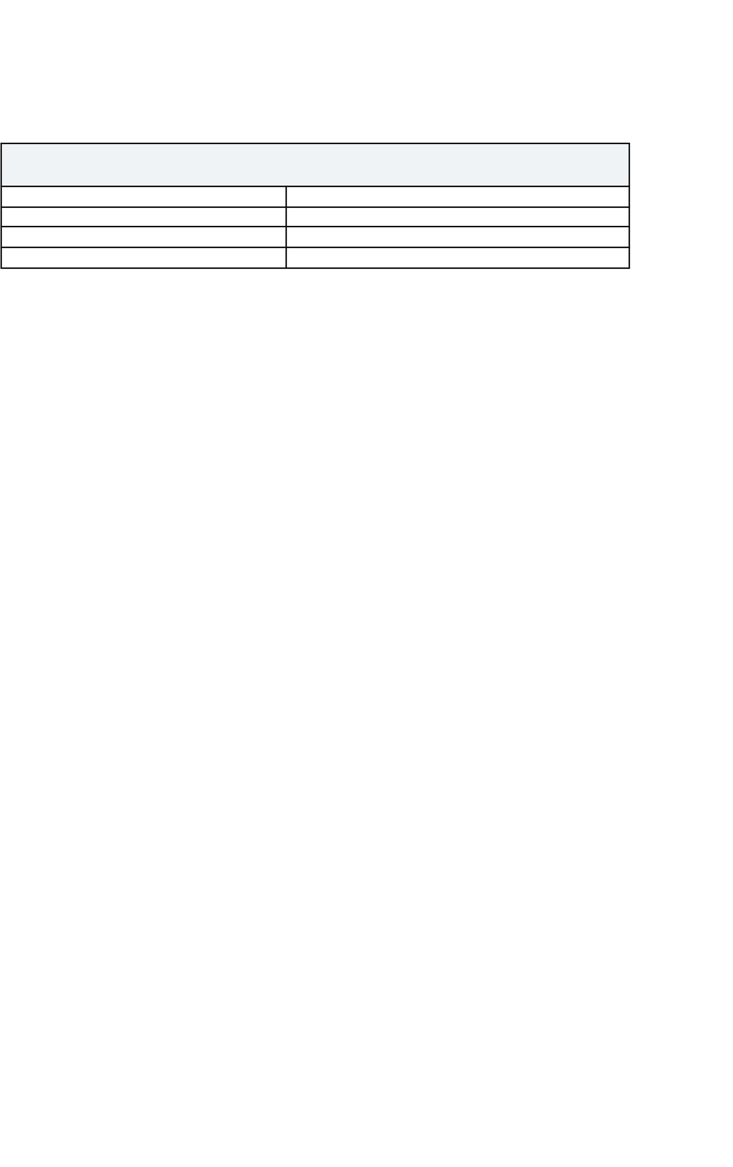

Project Overview:
Project Name: SHOPEZ : E-commerce Application
Description: ShopEZ is a web-based e-commerce platform that allows customers to discover products, compare prices, check availability, and complete purchases online.
The system includes product listings, category management, cart and checkout flow, order tracking, seller dashboards, and admin management modules. The platform aims to simplify the online shopping experience and ensure smooth interactions between customers, sellers, and admins. Project Version: v1.0.0
Testing Period: 2025-12-03 to 2025-12-10

Testing Scope:

The UAT will validate the end-to-end functionality of the system, including:
Customer & admin registration and login Product browsing & searching
Category-based and filtered product discovery
Add to cart & checkout Payment workflow
Order placement & confirmation
Order tracking (status updates) Seller product management Admin product approval flow
Notifications to customers Order history
Basic UI/UX validation
Error handling and form validations
Requirements to be Tested:
- As a customer, I want to register, log in, and browse products easily.
- As a customer, I want to search, filter, and view product details.
- As a customer, I want to add items to my cart and complete checkout quickly.
- As a customer, I want to view my order status and track delivery.
- As a seller, I want to add products and manage inventory.

- As a seller, I want to add products and manage inventory.
- As a system user, I want secure login and protected payment processing.

Testing Environment:

Testing Environment

- URL: https://github.com/Sumolegen/E-commerce.git

- Credentials:

  - Customer: customer@test.com / password123

  - Seller: seller@test.com / sellerpass
  - Admin: admin@test.com / adminpass

Test Cases:

Test Case ID
Test Scenario
Test Steps Expected Result
Actual Result
Pass/Fail

TC-001
Customer Registration
- Open website
- Click “Register”
- Fill form & submit
Account created and
redirected –
to dashboard

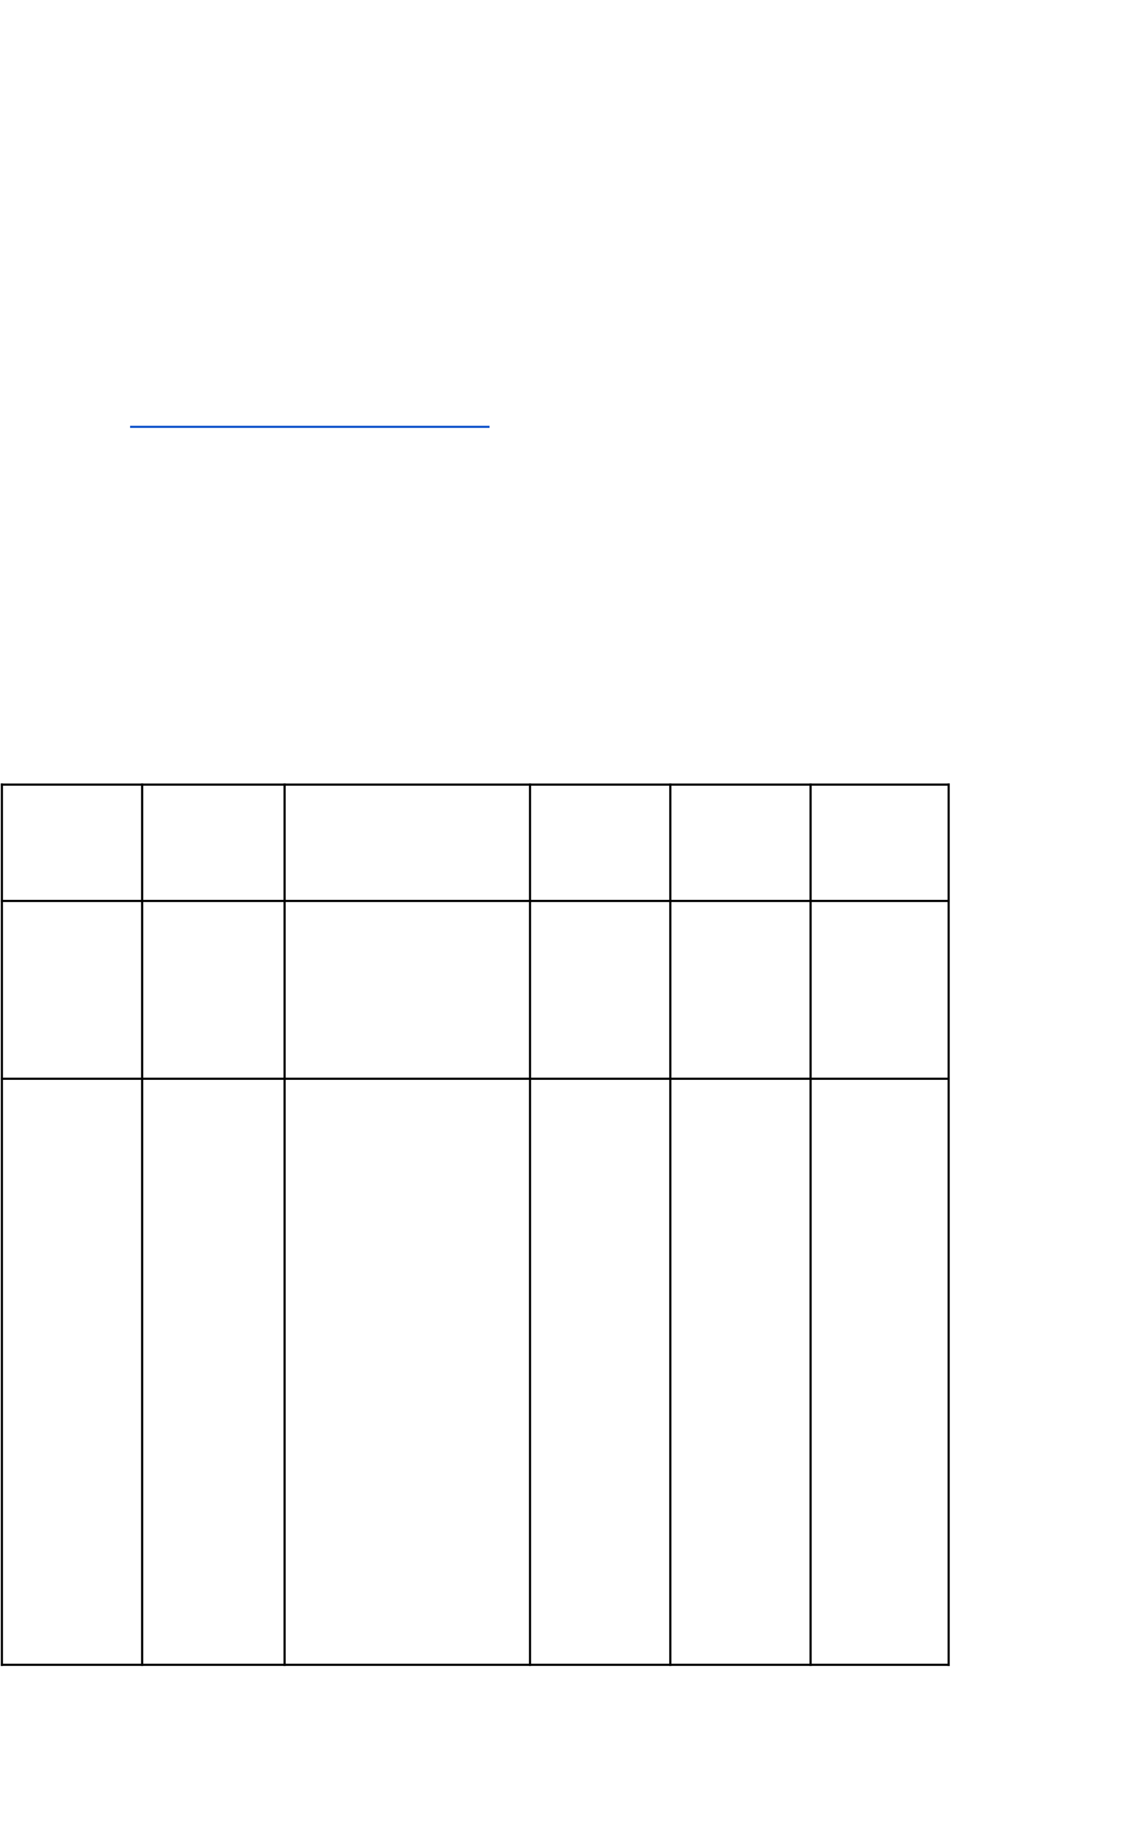
...

TC-002
...

Customer Login
...

- Open login page
- Enter valid credentials
- Click Login

Redirected to customer homepage
... ...

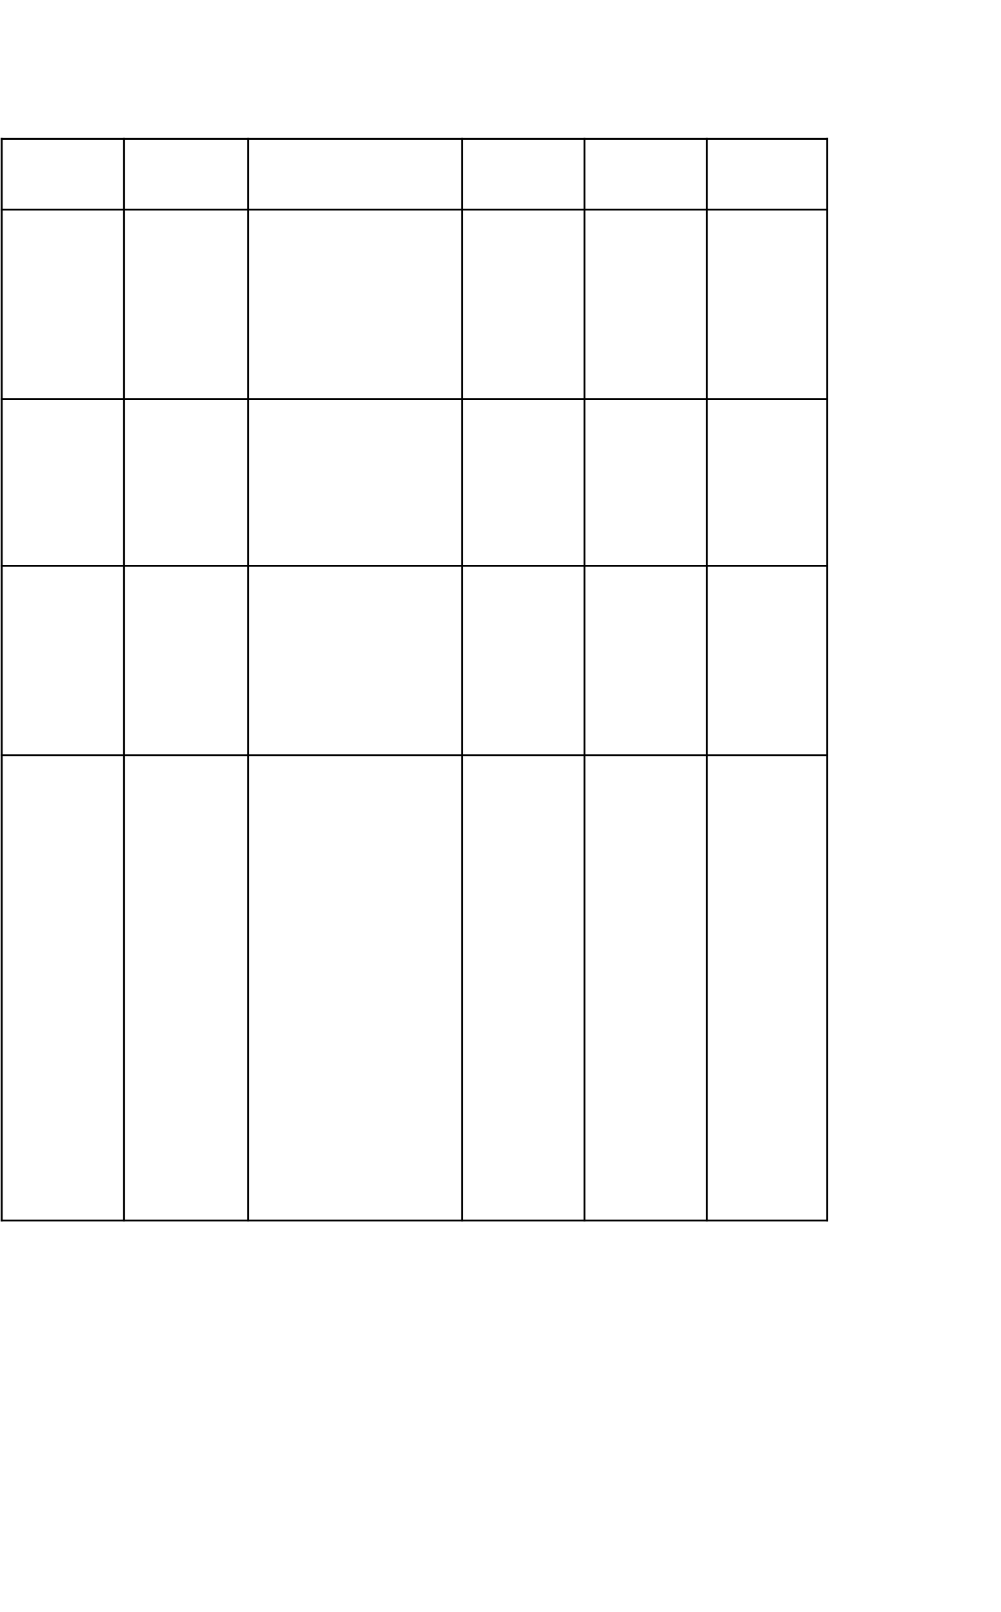
TC-003
TC-004 |  | 1. Select product | Product
 | Add to |  | added to
 | Cart | 2. Click “Add to Cart” | cart
TC-005 |  | 1. Open cart | Order

TC-006

Product Search

Checkout

Order Tracking
- Login as customer
- Use search bar

- Apply filters

- Click checkout
- Confirm address & payment
- Open “My Orders”
- Select order
Relevant product list displayed

placed & confirmati on shown

Order status displayed correctly

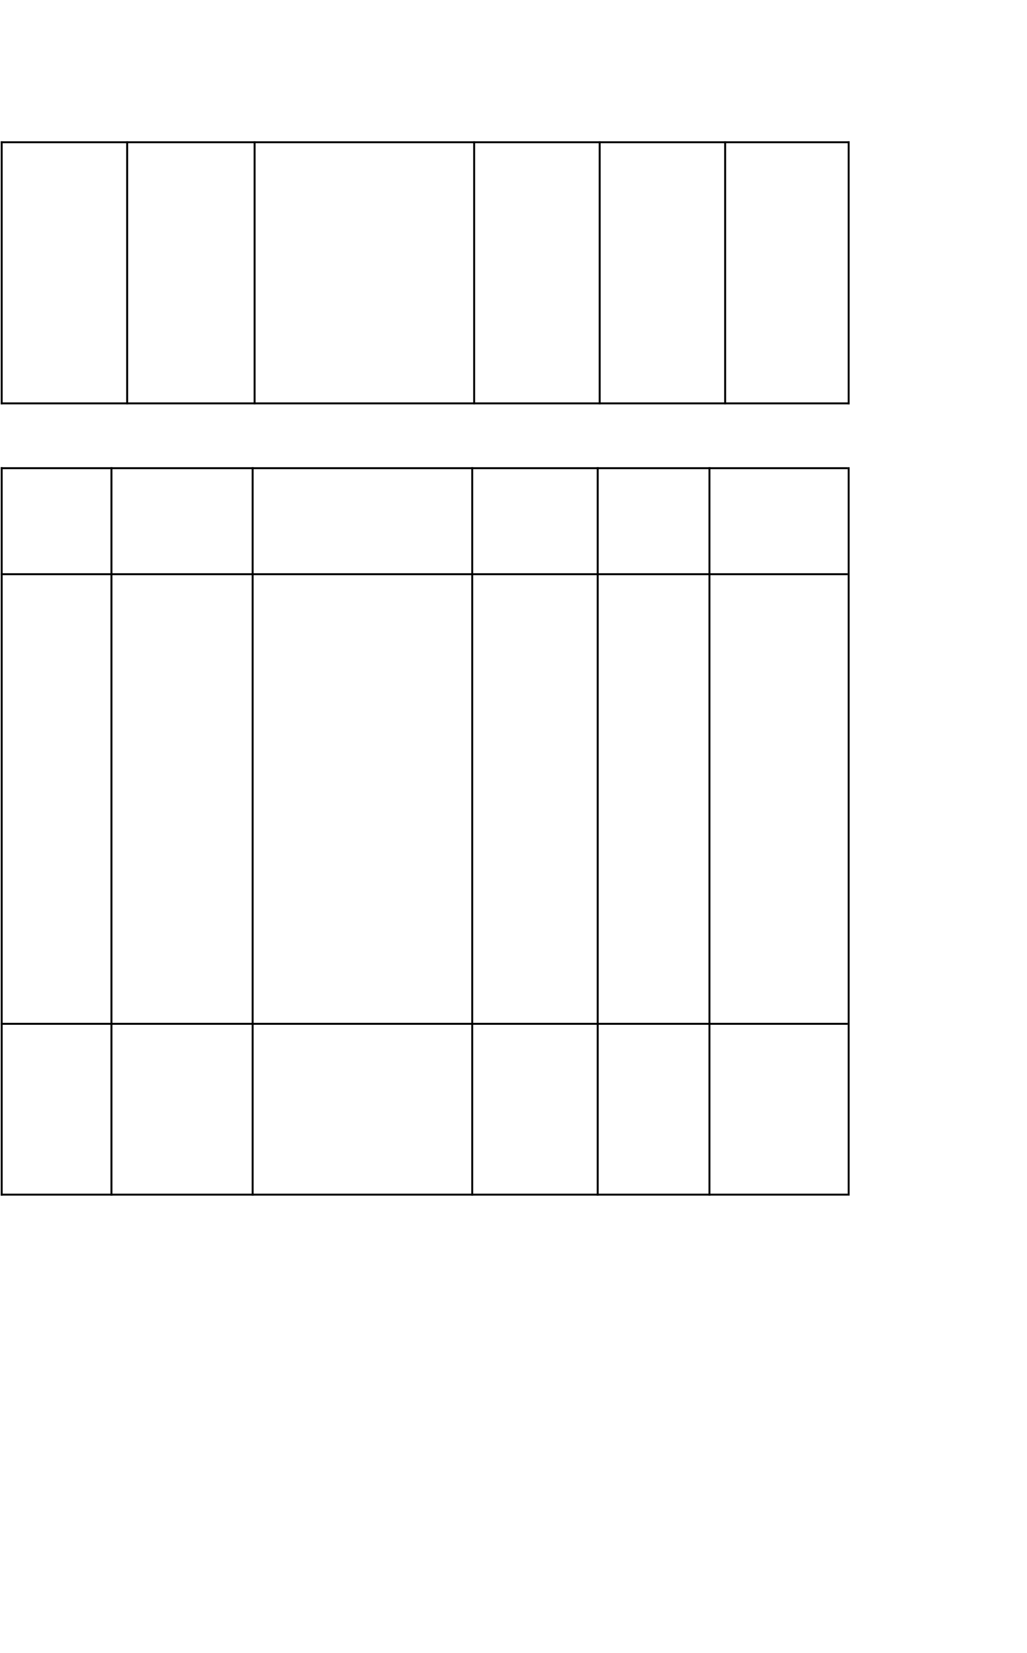
TC-007
Admin Approves Product
- Login as admin
- View pending products
- Approve/Reject
Product status updated; seller notified

Bug Tracking:

Bug ID Bug Description
Steps to reproduce Severity Status Additional
feedback

BG-001

Error in checkou t page
- Add item to cart

- Open checkout

High Open

Payment field not validating

BG-002 Incorrect
product stock display
- Login
- Search product
- Add to cart
Medium
Open Stock not updated in real-time

Sign-off:
Tester Name:
Sumathi K
Date: 03-12-2025
Signature: Sumathi
Notes:
- Ensure all purchasing flows (browse → cart → checkout → payment) are validated.
- Record all bugs with accurate severity and reproduction steps.

- Final deployment requires approval from Tester, Project Manager, and Product Owner

